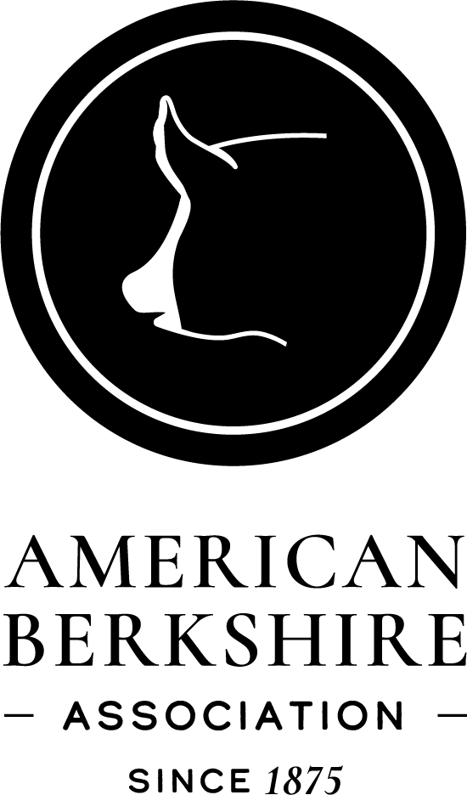

Membership Handbook

American Berkshire Association
2637 Yeager Road
West Lafayette, IN 47906
Phone: 765-497-3618
Fax: 765-497-2959
Email : Office@americanberkshire.com
Please note: As of Jan 1, 2023, this Handbook is still under revision. Check with the ABA office regarding any questions.

THE HISTORY OF THE BERKSHIRE BREED

Three hundred years ago – so legend has it – the Berkshire hog was discovered by Oliver Cromwell’s army, in winter quarters at Reading, the county seat of the shire of Berks in England. After the war, these veterans carried the news to the outside world of the wonderful hogs of Berks; larger than any other swine of that time and producing hams and bacon of rare quality and flavor. This is said to have been the beginning of the fame of the Reading Fair as a market place for pork products.
This original Berkshire was reddish or sandy colored hog, sometimes spotted. Later this basic stock was refined with a cross of Siamese and Chinese blood, bringing the color pattern we see today along with the quality of more efficient gains. This was the only outside blood that has gone into the Berkshire breed within the time of recorded livestock history. For 200 years now the Berkshire bloodstream has been pure, as far as the records are known today.
The excellent carcass quality of the Berkshire hog made him an early favorite with the upper class of English farmers. For years the Royal Family kept a large Berkshire herd at Windsor Castle. A famous Berkshire of a century ago was named Windsor Castle, having been farrowed and raised within sight of the towers of the royal residence. This boar was imported to this country in 1841, creating a stir in the rural press, which has seldom been equaled. From these writings, it appears that he must have weighed around 1,000 pounds at maturity. His offspring were praised for their increased size, along with their ability to finish at any age.
According to the best available records, the first Berkshires were brought to this country in 1823. They were quickly absorbed into the general hog population because of the marked improvement they created when crossed with common stock. At least one of the major “American” breeds has publicly admitted its debt to Berkshire blood in establishing its foundation. This breed carries identical color markings.
In 1875, a group of Berkshire breeders and importers met in Springfield, Illinois, to establish a way of keeping the Berkshire breed pure. These agricultural leaders of the day felt the Berkshire should stay pure for improvement of swine already present in the United States and not let it become only a portion of the “Common Hog” of the day. On February 25 of the same year, the American Berkshire Association was founded, becoming the first Swine Registry to be established in the world. This society drew forth an enthusiastic response from men working with the breed both in this country and in England. The first hog ever recorded was the boar, Ace of Spades, bred by Queen Victoria.
At that time most of the leading herds in this country were using some imported stock. Therefore, it was agreed upon when the society was established, that only hogs directly imported from established English herds, or hogs tracing directly back to such imported animals, would be accepted for registration. The breed today is descended from these animals recorded at the
time or from stock later imported. The most recent importation of English Berkshires was in 2005. Two imported boars have been made available to all breeders via artificial insemination.
In 1876, in the first Breed Publication, the following was printed, “The Berkshire meat is better marbled than that of any other breed of swine. That is it has a greater proportion of lean freely intermixed with small, fine streaks of fat making the hams, loins, and shoulders sweet, tender, and juicy. This renders the whole carcass not only the more palatable to persons in general but are unquestionably the healthiest food. Considering these facts, the Berkshire, above all others, should be the favorite swine among us. We ought to take all possible pains in breeding Berkshires in such a manner as to enhance this superior quality, not only for the home use but also for the foreign market.”
The American Berkshire Association in West Lafayette, Indiana maintains the records and registry of the most influential breed of swine in the history of the world.
The Berkshire Breed paved the way for better swine production and improvement in the United States and Europe, as well. Berkshires have had great influence upon the swine industry the past 100 years, and the Breed Association has made people aware of the importance of purebred animals. Types have changed in the swine industry due to economic needs, and Berkshires have played some of the most distinguishable roles in the Swine Industry. At the Chicago International Livestock Expositions, in all breed competition, Berkshires won champion individual carcass five years in a row and 11 out of 13 years. Berkshires won champion car lot 8 years in a row and 15 out of 18 years. These winnings have never been duplicated at any major show by any other breed.
During the past several years the Berkshire has made great strides of improvement toward meeting the demands of the swine industry. Selection pressure has been applied toward those traits of great economical importance – fast and efficient growth, reproductive efficiency and leanness without losing meat quality.
Today when many in the pork industry have emphasized leanness while sacrificing meat quality it is important that we re- emphasize what the founders of the American Berkshire Association knew in 1875. Berkshires produce a whole carcass that is well marbled. It is consistently sweet, tender, juicy and palatable. When consumers want pork that tastes good the American Berkshire above all others is their favorite, not only in the United States but also for the foreign market.
This is the background of the modern Berkshire hog. It is important because it explains why the Berkshire is such a true breeder when crossed on other breeds or on common hogs. His characteristics have been established and purified over a very long period of time. Breeders have been working at the task of improving him as far back as any record goes. He is indeed a splendid example of an improved breed of livestock.

3BMEMBERSHIP INFORMATION

Senior Membership
Membership in the American Berkshire Association is a privilege and is subject to the conditions and terms established by the ABA Board of Directors. You are encouraged to join the American Berkshire Association if you are interested in breeding purebred Berkshire swine. A Senior member is anyone over 21 years of age and a resident of the United States (or a corporation incorporated under United States law). The Senior Membership fee is $10.00. This fee is paid only one time and should accompany the application for membership. When you apply for a Senior Membership, you should clearly indicate the name in which the membership is to be recorded. If registrations are to be recorded in the name of a farm or ranch, memberships should be in the name of the farm or ranch; if to be recorded in the name of a partnership, the membership should be in the name of the partnership and at least two officers of the corporation must sign the application. At the time you apply for membership, you should select the herdmark of your choice. Senior Member herdmarks are made up of three or four capital letters. If they are not already in use by another breeder, they will be assigned to you. The first year you must pay the $10.00 Senior Membership fee and the $75.00 annual maintenance fee (see below).

Active Status
To be an active Senior Member, an annual maintenance fee (annual dues) of $75.00 is due and payable on January 1st each year. With this
$75.00 annual maintenance fee, the member will automatically receive a yearly Seedstock Edge subscription, member rates for registration and transfers. An Active Senior member is entitled to participate in the election process of the American Berkshire Association. The second criterion for active membership status is to record breeding stock – at least two litters a year.

Types and Terms of Membership. Membership in this Association shall be for life, and as long as the holder is actively recording/raising purebred Berkshires. The Association shall have two types of membership – Registered Herd and Commercial Herd.
A Registered Herd will individually ear notch all pigs and will record litters. Failure of a Registered Herd member to record two (2) purebred litters of Berkshires in the twelve (12) months prior to the Annual Meeting of the Association, shall automatically and without notice cause the member to become an Inactive Member, without power of vote. However, Inactive Registered members shall be reinstated to all Privileges of membership upon recording two litters in a calendar year and paying the annual maintenance fee.
A Commercial Herd will ear notch all offspring with a unique herd notch and pay an annual fee (set by the Board of Directors) based on the number of sows owned. Failure of a Commercial Herd member to own at least two (2) sows or to pay the annual fee shall automatically and without notice cause the member to become an Inactive Member, without power of vote. However, Inactive Certified members shall be reinstated to all Privileges of membership upon owning two sows in a calendar year, paying the fee per sow and paying the annual maintenance fee. If you are interested in being a Commercial Herd, contact the ABA office for a herd notch.

Junior Membership
Junior Memberships are available, at no charge, to all breeders under 21 years of age. Junior memberships may register and transfer under the same conditions as Active Senior Members. At the time you apply for membership, you should select the herdmark of your choice. Junior herdmarks are made up of three or four capital letters. If your herdmark preference is not already in use, it will be assigned to you.

REGISTRATION OF ANIMALS
In order to register a litter of pigs, you must obtain an Application for Registration from the American Berkshire Association. If the sire of the litter was used by Artificial Insemination (A.I.), you are required to submit an A.I. Breeding Certificate. This certificate must be obtained from the A.I. firm where the semen was purchased. Most AI firms complete the AI certificate online. You should contact the AI firm before sending in your litter registration.

Application for Registration
To complete the application, you will need the owner’s herdmark, owner’s breeder number, Dam & Sire ear notch and registration number, litter number, farrowing date, ear notches of boars, boar name (if desired), ear notches of gilts, gilt names (if desired), breeder name and address, number of pigs total born, and number born alive. Sow Productivity Information is determined by completing the 21 day information including the number weighed, litter weight, date weighed, and parity. There is no fee to participate in the SPI program.
See a price sheet for current costs to register litters and transfer pigs. Individual registration certificates (pedigrees) or litter certificates are available. Please contact the ABA to indicate the type of registration certificate you wish to receive. (See below for litters over 2 years of age.)

DNA Banking of Sires and Stress Testing
Effective January 1, 2012, the ABA requires all sires used to register Berkshire litters be stress tested (in addition to being DNA banked). The stress results can be negative, carrier or positive for recording purposes, however if the pedigree says the boar is a negative mating and the boar does not test negative, we will follow the Standard Procedures for DNA Testing and Report of Results (found later in this handbook).
Effective January 1, 2005, the ABA requires all sires used to register Berkshire litters have a DNA sample on file at the office before the litter will be recorded. The steps to fulfill this requirement are:
- Order a blotter card (for each boar you use) from the ABA office (you cannot use a Genalysis card for this requirement). The cost is
$5/card.
- Follow the directions that come with the card. This involves pricking the boar’s ear, putting a few drops of blood in each circle on the card, allow card to dry completely and mail to the ABA office.
A sire only needs to have one sample on file, no matter how many litters he sires or who uses the boar.

4/24

If you artificially inseminate, make sure the person/firm you purchase semen from has sent a blood sample to the ABA office. Testing may be done on these samples at the time they are sent in or later.
If you are a certified herd for the 100% Pure Berkshire meat program, you already meet this qualification. When you send a blood sample on a herd boar to the office to be tested for the stress and Napole genes, the card is returned to the office to be put on file.
All DNA samples will remain property of the ABA and will be stored at the national office. Genetic tests may be required as the Executive Committee or Board of Directors determines, including, but not limited to parentage verification. If there is justifiable cause to question the parentage of a pig, the Executive Committee and/or Board of Directors may require the pig, sire and dam’s sire to be genetically tested, the expenses of which shall be allocated as the Committee/Board determines. The results of this test, together with other available information, may be taken into consideration by the Committee/Board in its determination of the pig’s parentage as recognized by the ABA. Such genetic testing shall be done by an organization approved by the ABA.
Effective January 1, 2005 no litters will be recorded if a DNA sample is not available from the sire. The ABA Board encourages breeders to test all sires for the stress gene to verify the stress status.

Litters over 2 years of age
**Starting January 1, 2008, no animal older than two years of age is eligible for registry in the American Berkshire Association unless approved by the ABA Board of Directors. The cost for recording a litter over 2 years of age will be $100/litter (after approval from the Board). Exceptions for imported Berkshires that have pedigree registrations from a foreign registry that is recognized by the American Berkshire Association may be considered by the American Berkshire Association Board of Directors.

Stress Results on Pedigrees
The Stress status of an animal is denoted on the pedigree under the animal’s name.
HAL-1843*nm—Negative HAL-1843*mm—Carrier
HAL-1843*dm—Positive Nothing listed—animal’s stress status is unknown

If both parents are negative, this is considered a negative mating and all offspring will be negative.
In the pedigree system we denote if an animal has actually been tested (vs. a negative mating). Therefore, if you test an animal, please send that result sheet to the office so we can enter it into the system.
The American Berkshire Board of Directors regret to report that we have experienced some incidents where pigs that are a “negative mating” on the pedigree have tested to be stress carriers. Therefore the Board would like to go on record to recommend that you test any boar and/or gilt purchases that you. You should do this before they are used in herd reproduction, or better yet, within 30 days after purchase. (See Code of Fair Practice – page 15).
Be sure to check registration papers to make sure you know the stress status of your animals. Be sure to check the registration papers every time you record pigs to make sure a stress status somewhere in the pedigree hasn’t changed.

Berkshire Breed Character
The Berkshire office and Board members have received phone calls of questions and concerns in reference to Berkshire breed character. Breeders should use good judgment in selling Berkshires with red hair or too much white.
The Bylaws of the American Berkshire Association state the following:

Article XIX—Markings and Identification Requirements
Section 1. Color. The ideal color pattern is black with six white points (face, four socks, tip of tail). Less desirable, but acceptable, are sandy colored hair in the areas where white and black border. Color Qualifications for Registration (boars, gilts and barrows must meet the following color requirements in order to be recorded): A Berkshire must have white on the face and tail, unless the tail is docked. Three of four legs must be white. A Berkshire must not have a spotted or mottling pattern – an intermixture of black and white and/or red hair that is larger than a contiguous 93.5 square inches area anywhere on the body of a mature pig (approximately a 8 ½ x 11 square inch area, on a 50 lb pig, this would be equivalent to 15 square inches, or a 3 x 5 area). A Berkshire must not have an area of white skin that exceeds 93.5 square inches of contiguous solid white skin on the upper 2/3 of the body (15 square inches on a 50 lb pig). A Berkshire cannot have white skin or hair that continuously encircles the body anywhere between the base of the ear and the base of the tail. From the base of the ear forward, a Berkshire cannot be solid white. A Berkshire cannot have any skin color besides black and white (includes red or sandy colored skin).
Section 4. Disqualification for Registration of Breeding animals. The presence of one or more of the following are disqualifications for registration:
a) less than 12 teats, b) the presence of one or more swirls on upper half of the body, c) total blindness, d) rectal or uterine prolapse, e) hermaphroditism, f) atresia ani; g) cryptorchidism or monorchidism; h) scrotal and/or umbilical hernia, and i) ear carriage that “breaks” to the point in which ears are continually directed in a downward angle.
Many of our Junior Shows have classification guidelines which entries must pass in order to show. We currently do not have any classification guidelines for our National Shows. Some people feel that the sale ring serves as the evaluation point to cover breed character. The Board asks the breeders and judges to use proper discrimination for good breed character in showing and selling Berkshires. We realize that a mating of two Berkshires with good breed character can still give you some Berkshire pigs with too much white. However, good selection pressure over time can help improve this problem.

Berkshire Classification Guidelines:
- Must be a black and white animal with erect ears exhibiting Berkshire character.
- Must have white on all four legs, face and tail (unless tail is docked). One of the white leg points may also be missing.
- Must be ear notched within seven days of birth.
- Must NOT have a solid white or a sold black face from the ears forward.
- Must NOT have a solid black nose (rim of nose).
- White is allowed on the ears, but NO solid white may appear on the ears.
- Occasional splash of white may appear on the body.

Standard Procedures for DNA Testing and Reporting of Results

The following procedures will be followed when collecting DNA samples at shows:

- DNA Collection at the Show:
  - Needed information on DNA cards and verification forms for tested animals will be completed by ABA or Team Purebred staff before sample is collected and made available for staff that will be collecting the sample.
  - DNA collection process (each tested animal):
    - Exhibitor or legal guardian must be present.
    - Exhibitor or legal guardian must sign verification form after DNA has been collected.
  - DNA samples and verification forms will be returned to the ABA office to coordinate testing process.

These procedures will also be followed any time an animal is tested for stress (or other DNA testing as it becomes available).

- Stress Tests:
  - If the tested animal is verified as stress negative the animal passes and the result will be updated in the pedigree system. The exhibitor will receive all awards.
  - If the tested animal is verified as either a ‘carrier’ or ‘positive’ for the stress gene the animal fails. The following procedures will then be followed:

Negative Mating (both parents are negative in the pedigree system):
  - A parentage test will be done to check the pig against the sire.
  - If the pigs pass the parentage test:
    - A stress test will be performed on the sire if he is previously untested (negative mating).
    - If he fails the stress test, the pig in question will lose the negative stress status in the ABA pedigree system, but will keep its pedigree. All littermates will also lose the stress negative status.
    - If he passes the stress test or if a stress test was previously performed to show the sire as negative, the ABA will try to obtain DNA from the dam to be tested for stress.
      - If the dam passes the stress test, there will be a parentage test to see if the dam is truly the dam. If she is not the dam, we will follow the procedure spelled out in c. below but for dams instead of sires.
      - If the dam fails the stress test, the pig in question will lose the negative stress status in the ABA pedigree system, but will keep its pedigree. All littermates will also lose the stress negative status.
      - If a sample from the dam is not available the animal will be considered to have failed the testing and will lose its pedigree. All littermates will also lose their pedigrees.
  - If the parentage test states that the listed sire is not the sire
    - Breeder must provide a list of possible sires (no more than 10) with DNA samples on ABA blotter cards to re-test (this testing is done at the breeders expense).
    - The re-testing procedure must be completed all at once (a single GeneSeek order) and must be submitted within 30 days of the initial parentage result.
    - This process follows the same steps detailed in section V.
    - If breeder opts not to attempt to rectify the parentage, then a final ‘Fail’ result is determined and all pigs in the litter will lose their pedigrees.

Original pedigree listed an unknown mating (at least one of the parents is not negative in the system), therefore the exhibitor or breeder needed to test the pig before the show:
  - The ABA will try to obtain the original DNA.
    - If the DNA is available, the samples will be compared to make sure they come from the same pig.
      - If this sample matches, parentage testing will be completed (see section III) and the breeder will be considered at fault
      - If this sample does not match, parentage testing will be completed (see section III) and the person who sent in the original DNA sample for testing will be considered at fault
    - If the DNA is not available, we will follow procedures in section III with parentage testing.

Parentage Test Procedures
  - The first test completed will be a SNP test:
    - If there are less than 2 exclusions the animal passed the parentage test.
    - If there are 2 exclusions the animals will be re-tested on the microsatellite panel. See “b” below.
    - If there are more than 2 exclusions the animal failed the parentage test.
  - The second round of testing (microsatellite panel):
    - If there are 1 or fewer exclusions the animal passed the parentage test.
    - If there is more than 1 exclusion the animal failed the parentage test.
  - The above procedures (a & b) will be followed for any boar the breeder tests against (see section III c).

Breeder Options (at breeder’s expense):
  - If ‘fail’ result on SNP panel is determined, the breeder has the option to ask for re-test on the Microsatellite panel.
  - If a final ‘fail’ result is determined, the breeder has one opportunity to rectify the parentage (section III 3).
  - Each breeder is allowed to have one mistake with parentage (lifetime accumulation); once this opportunity is used, all future initial test results stand (any time stress or parentage testing is completed on future animals), and no further options to rectify results are available.

- ABA Actions and Reporting of Final Results (after the above sections have been fully completed):
  - Initial Pass Result – The ABA office will notify Team Purebred personnel of results. All corresponding awards and premiums will be mailed.
  - Initial Fail Result:
    - ABA will notify Team Purebred personnel of results.
    - ABA personnel will:
      - Notify the breeder of the available breeder options (section III c), then
      - Notify the exhibitor of the current status of the process.
  - Parentage test rectified by breeder:
    - ABA will notify Team Purebred personnel of results.
    - Team Purebred personnel will notify the exhibitor and mail corresponding awards.
    - The ABA will make appropriate changes in pedigree system and notify all current owners of each animal in the litter.
  - Final Fail Result:
    - ABA will notify Team Purebred personnel of results.
    - ABA personnel will:
      - Notify the breeder of ABA policy for failed parentage results outlined in section VII., then
      - Notify the exhibitor of the current status of the process.

ABA Policy Regarding Failed Parentage Tests
  - The ABA will cancel the pedigree on each animal in the litter.
  - A letter will sent to each owner to notify them of cancelled pedigree(s).
  - If the breeder of a GILT is found at fault, they must:
    - Pay the exhibitor’s premiums to the ABA. The ABA will then reimburse Team Purebred.
    - Refund the original purchase price of the animal to the exhibitor.
    - Pay the commission to the ABA if the animal(s) sells through an ABA event (This is for gilts that are double entered and shown/sold at an ABA event). The total purchase price will be refunded to the buyer by the ABA, since this animal will no longer have a pedigree.
    - Pay for any additional DNA tests outside of the original stress test completed by the ABA (this includes parentage testing).
    - Not be considered a member in good standing with the ABA and will be unable to register any litters or participate in any events if they fail to comply with above rules i-iv.
  - If the breeder of a BARROW is found at fault, they must:
    - Pay the exhibitor’s premiums to the ABA. The ABA will then reimburse Team Purebred.
    - Refund the original purchase price of the animal to the exhibitor.
    - Pay for any additional DNA tests outside of the original stress test completed by the ABA (this includes parentage testing).
    - Not be considered a member in good standing with the ABA and will be unable to register any litters or participate in any events if they fail to comply with above rules i-iii.
  - If the exhibitor of a GILT or BARROW is found at fault:
    - All awards and premiums will be revoked. Exhibitor has 30 days to return awards to the Team Purebred office or will not be considered a member in good standing with the ABA and will be unable to register any litters or participate in any events.
    - In the event that the breeder/exhibitor has been awarded a trailer, it must be returned to the dealer and any expenses required to transport, remove lettering, and/or return to the dealership are the responsibility of the breeder/exhibitor.

**The term breeder/seller may also refer to a boar stud, exhibitor, or an interim owner.

Related Policies:
  - All parentage tests must be coordinated through ABA. Results will not be accepted from tests submitted by the breeder.
  - All DNA samples submitted for DNA banking requirements must be on a card from the ABA office and have a sufficient sample.

  - No test results will be released to anyone outside of ABA staff and Board President until all needed secondary tests are completed.
  - The need of any further testing on ‘Fail’ results will be determined and coordinated by ABA staff only.
  - No ‘internal R&D’ results will be released to anyone outside of ABA staff until permitted by the ABA Board.
  - All submitted samples (regardless of test result) will be retained by ABA, and no submitted DNA samples will be released back to the breeder or exhibitor
  - Failed test results will not be publicized except in the normal listing of canceled pedigrees published in the ABA newsletter and Breeders Digest.

Directions for Registration Application and Sow Productivity Data
General Information – Please print (in ink) all information clearly. Registration – Fill out entire white areas for registration.
Sow Productivity – Fill out white and shaded areas for sow productivity and registration (shaded area not required for registration purposes).
Ear Notching – No litter or animal in any herd shall be eligible to record unless each pig in the litter is distinctly ear notched at farrowing time for litter and individual pig identification by the Official Berkshire Ear Notching system (see page 10).
Owner’s Herd Mark – Print your herd mark in the designated box. Please print plainly so it cannot be misread. If you do not have a herd mark, you must obtain one from the American Berkshire Association. (Fill out the application for membership form).
Owner’s Breeder Number – Everyone who has done business with the American Berkshire Association has received a “Customer Number” or breeder number. Please print your breeder number in the box. If you do not have a breeder number the Association will assign you a number with your first order. Be sure you use your breeder number on all orders and payments.
Dam/Sire Ear Notch and Registration Number – Ear notch and registration number of sire and dam must be accurate. If either the ear notch or the registration number are incorrect the application will be rejected. The ear notch and registration number for each animal is located on their registration certificate. If the sire is not owned by you, you must include either a Breeding Certificate or Artificial Insemination Breeding Certificate. A Breeding Certificate is used if you sold a bred gilt, borrowed someone else’s boar or took your gilt to someone to breed. An AI Certificate is used if you purchased (or was given) semen from a boar not belonging to you.
Litter Number – Litter number must be the same as the ear notch for that litter. Litters must be notched in consecutive birth date order. For example, litter #2 cannot be farrowed before litter #1. Litter notch must be placed in the right ear of each pig before they reach the age of seven days. The Official Berkshire Ear Notching system must be used. Breeders should notch the first litter born on or after January 1 of each year with litter ear notch number 1 and continue to notch each successive litter born through June 30 in numerical order. Then the first litter born on or after July 1 of each year will be notched with litter ear notch number 1 and each successive litter born through December 31 will be notched in numerical order.
Farrowing Date – Date of birth. Month-day-year (Example 4/25/01).
Ear Notches of Boars – Print the individual ear notches of all boars in the spaces provided. (Example: 1-2-3-4, etc). You do not need to include the litter notch. If there are more than 10 boars to record in a litter use additional spaces under the gilt sections and designate the boars with a “B” along with their individual notch (Example: B-1, B-2). If a boar pig has been castrated, designate that it is a barrow by placing an “x” after the ear notch (Example: 3x, 4x).
Boar Name – If you prefer to name the boar pigs, print that name in the space provided. All boar pigs from that litter will be given the same name. By leaving this blank, the computer will automatically name all the boar pigs the same as their sire. For example, if the sire is named ABA3 Citation 32-4, all the boar pigs will receive the Citation name along with your herd mark, year of birth and their own litter and individual ear notch. The name given to the boars cannot exceed 17 spaces.
Ear Notches of Gilts – Print the individual ear notches of all gilts in the spaces provided (Example: 5-6-7-8). You do not need to include the litter notch. If there are more than 10 gilts to record in a litter, use additional spaces under the boar section and designate the gilts with an “S” along with their individual notch (Example: S-5, S-6).
Gilt Name – If you prefer to name the gilt pigs, print that name in the space provided. All gilts from that litter will be given the same name. By leaving this space blank, the computer will automatically name all the gilt pigs the same as their Dam. NOTE FOR SOW PRODUCTIVITY RECORDS: Gilt name should be the same as the sow family name reported on your prior sow productivity forms. Gilt name will automatically become the sow family name with the new joint form.
Name Change – Name changes for Boars and Sows will be allowed only after that particular animal becomes a Sire or Dam. Print the new name on the original pedigree and mail to the American Berkshire Association. The cost for a name change is $5.00.
Breeder Name and Address – “Breeder” is the person who owned the Dam of the litter at the time she was mated (bred) to farrow the litter. Please include complete name and address with zip code. If breeder is different from owner, please include breeding certificate signed by the breeder. If “breeder” is same as “owner,” leave this blank. “Owner” is defined as the person who owned the Dam at the time she farrowed the litter.
Number of Pigs – Total Born: Include all pigs born – both alive and dead. Born Live: Number of pigs born alive. Signature – Be sure to sign the bottom of the registration form.
Complete the Shaded Area for Sow Productivity (this section is optional):
After Transfer – This is the number of pigs the sow had an opportunity to raise after the litters are evened up. For the best data a sow should not nurse less than 6 pigs nor more than 12. If a pig is lost for no fault of the sow, it should not be included here. Pigs that are laid on or are lost because the sow stepped on them should be included here.
21 Day Information
Number Weighed – Include all the pigs the sow nursed.
Litter Weight – Total weight of the litter. Weights must be taken between 14 and 28 days of age.
Date Weighed – This is the date when the litter was weighed. Weights must be taken between 14 and 28 days of age.
Parity – This is the number of litters the sow has farrowed. A parity of 1 is a sow with her first litter, a 2 is a sow with her second litter, etc.

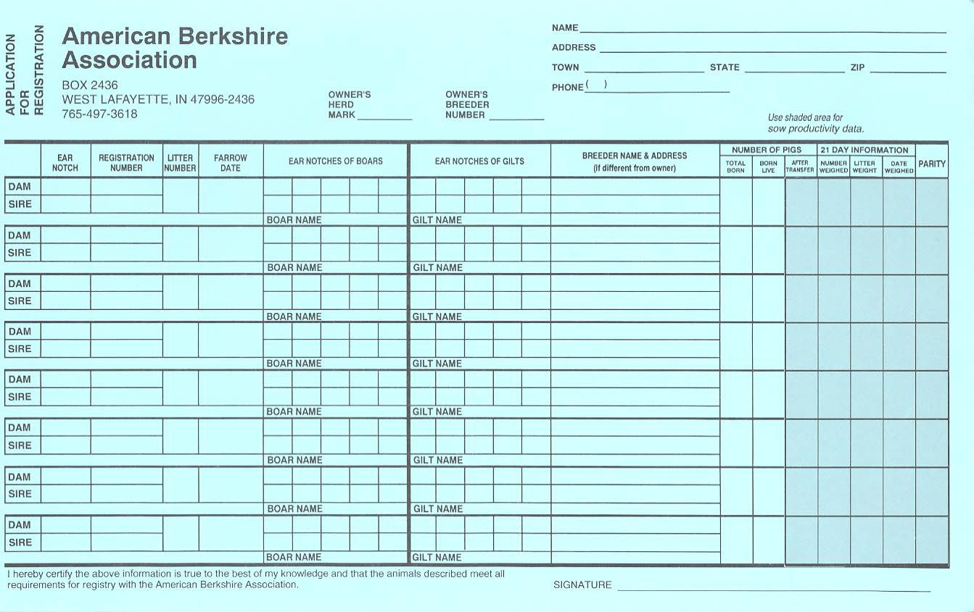
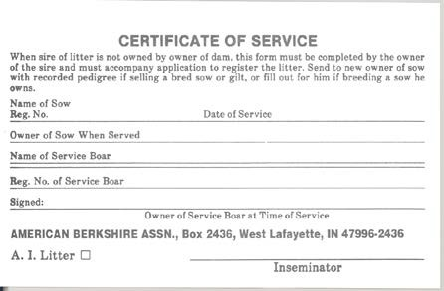
Certificate of Service/Breeding Certificate

AI Certificates – If you purchase or are given semen, you must have an AI certificate from the owner of the boar in order to record the litter. Most boar studs submit these AI certificates online. When registering a litter, if you do not have the boar’s ear notch and registration number, be sure to write the boar’s name so we can match the AI certificate to the correct litter.

Certificate of Service – A certificate of service is used when you borrow a boar owned by someone else or take your female to another location to be bred by a boar you don’t own. The owner of the boar should give you a Certificate of Service in order to record your litter(s). Certificate of Service are sometimes referred to as Breeding Certificates. Certificates can be printed from the ABA website.

**No litter or animal in any herd shall be eligible to record unless each pig in the litter is distinctly ear notched at farrowing time for litter and individual pig identification by the ABA Notching System, based on the Universal Ear Notching System, also known as the 1-3-9-27-81 system. Each litter is to be ear notched in consecutive order. Start with litter #1 with the first litter farrowed after January 1, and again after July 1. If you only have a few sows you can notch consecutively throughout the year. However you should start over on January 1 every year. You should not have duplicate litter notches in any farrowing season (January 1 – June 30 and July 1 – December 31).

5BTYPES OF HERDS

The American Berkshire Association currently has two types of herds, the Registered Herd and the Certified Commercial Herd. A Registered herd is the normal recording of a Berkshire litter, with each animal having an ear notch and pedigree.

A Certified Commercial herd ear notches all the pigs produced with an identical notch identifying the herd. There will not be pedigrees on the offspring. A breed representative will visit your farm each year.

The American Berkshire Association currently has a meat program – 100% Pure Berkshire. Please review the ABA website or contact the ABA office for more information on this program. There will be Certified Registered Herds, Certified Commercial Herds and Certified Feeder Pig Finishers.

PEDIGREE INFORMATION
One of the most valuable services the American Berkshire Association offers is the pedigree. A pedigree is a documented ancestry of an animal. This pedigree is necessary for predicting the progeny performance and is a tool to assist in making wise breeding decisions that can lead to breed improvement and production efficiencies. This pedigree has increased in value dramatically in recent years, as it is now a true performance pedigree that is based on all the relative date accumulated throughout the STAGES program. If you purchase a Berkshire animal, be sure to get a registration paper issued by the American Berkshire Association.

Reading a Pedigree:
- Animal’s official name and registration number. The name starts with herdmark unique to each breeder and ends with the animal’s ear notch.
- * HAL 1843 Stress Gene: “nm” – normal status, “mm” – carrier status, “dm” – positive status
- Animal’s pedigree including parents and grandparents and their Sow Productivity Index.
- Individual information including registration number, sex, ear notch and birth date.
- Litter performance information.
- Breeder’s name and address.
- Individual EPD’s and Indexes on the date the certificate was issued.
- Current owner’s name and address and date of sale.

Individual pedigree:
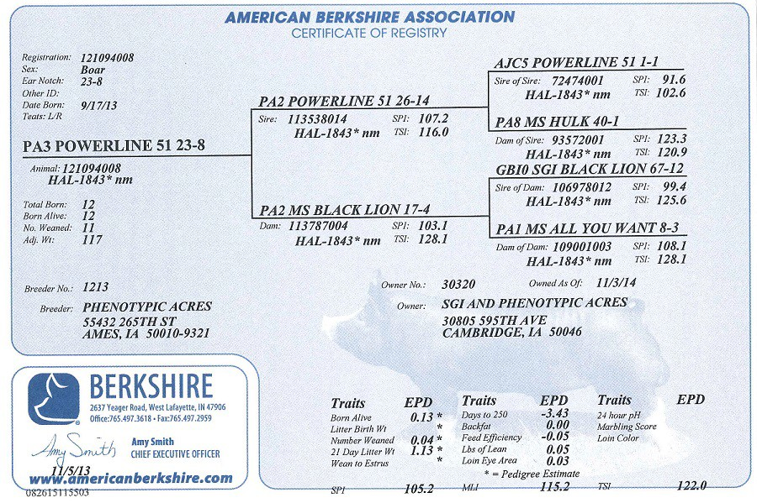
4
1
2
3
5
6
8
7

Litter Certificate: Back of Pedigree to Transfer

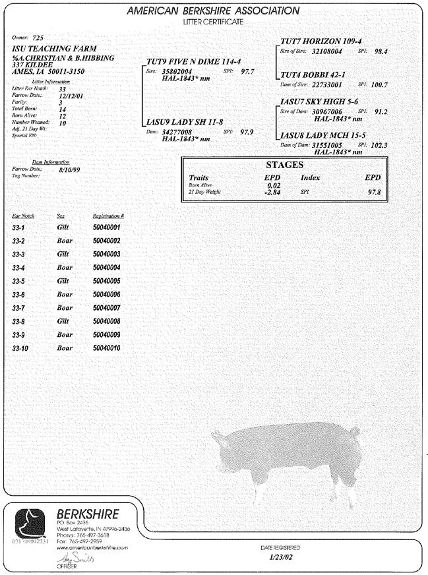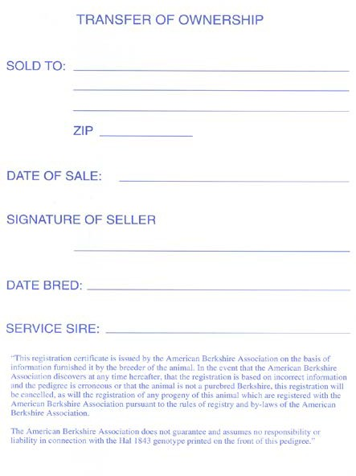
6
3
5
7
4

TRANSFERS

The American Berkshire Association holds the certificate of registration as an integral part of every purebred transaction. In every change of ownership of a registered animal, the seller shall furnish to the buyer a certificate of registration for the ABA showing transfer of ownership to the buyer. Transfers are billed and mailed back to whoever sent them in. If the seller mails the transfer to the ABA and would like us to mail it to the buyer, we can do that however there must be a note included with the transfer telling us to do so. To transfer a registered animal, you must complete the required information on the back of the animal’s pedigree or obtain and complete a Group Transfer Form from the American Berkshire Association and mail it to the ABA. The information for Date Bred and Service Sire is for bred gilts only. Please include the registration number under Service Sire. See the price sheet for current costs to register litters and transfer pigs.

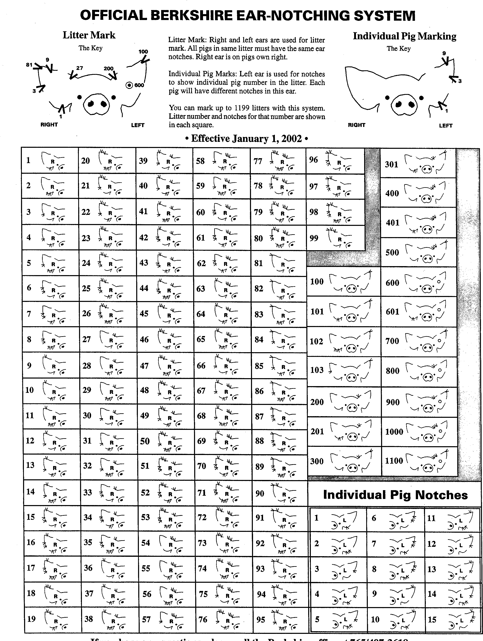

Shows and Sales
The American Berkshire Association is involved in four shows a year. The Southwest Type Conference (early March), The Exposition (June), Summer Type Conference (July) and the Fall Classic (Nov)that are managed by the American Berkshire Association. See the website or newsletters for the actual dates

Show | Dates | Location | Farrowing Dates
Southwest Conference | First of March | Belton, Texas | July 1 and after
Exposition | 2nd week of June | Des Moines, Iowa | October 1 and after
Summer Conference | End of June | Springfield, Illinois | December 1 & after
Fall Classic | 3rd week of Nov. | Duncan, Oklahoma | March 15 and after *UPDATED

Show and Sale Rules for Events
Beginning June 1, 2016
***This is a basic set of show and sale policies that will apply to all ABA events. Please keep it in a convenient location and use it as a reference guide for both you and your veterinarian for upcoming shows. However, always refer to each specific show’s rules for any needed changes or additions.***
- No entries will be accepted unless accompanied by current entry fee on all animals entered.
- Entry fees are $40 per head entered, unless otherwise designated on the entry form. Late entries will be double price. ALL entry fees are non-refundable. All entries must be recorded at least two (2) weeks prior to the date of the show or a rush fee of $75 per litter will be charged in addition to the $36 litter registration fee (litter recordings over 90 days of age).
- Entries will be limited to 4 animals in each show category (i.e. 4 boars, 4 bred gilts, and 4 open gilts) per exhibitor per show.
- Pedigrees must be submitted at check-in at the show and must have stress negative status printed on the pedigree. The buyer has the right to test any animal purchased within 60 days of the sale and receive a full refund plus testing costs if an animal is found to carry the stress gene. This guarantee is solely between the buyer and seller, and the ABA assumes no liability in connection with this warranty.
- All hogs must have a minimum of 6 quality teats on each side (no pin nipples or inverts will be accepted towards count) to be eligible to show. Underlines will be checked by the show committee at the time of weigh-in.
- All hogs must meet all registry requirements, including no swirls on the upper half of the body.
- All hogs must be owned by the person/firm at least 30 days prior to the date of the show.
- All bred gilts must be within 60 days of farrowing at the time of the show. Bred gilts must be bred to a registered Berkshire boar, must be bred to farrow before the gilt is 14 months old, and must be accompanied by a signed breeding certificate. The Service Sire must be STRESS NEGATIVE.
- Any evidence of fresh ear notches will automatically disqualify the animal from both the show and the sale.
- The judge and/or auctioneer will select the hogs that will be in the sale. We have the right to not put all hogs from the show in the sale. If a hog is listed in the sale catalog, it must come to the sale ring unless excused by show officials (only granted in case of injury or illness). If your animal is not selected but you would like to sell, you can consign your hog to the sale within 15 minutes following the champion drive.
- Each exhibitor agrees to sell each and every animal listed in the sale catalog and to not offer any exhibited animal for sale before the end of the auction. Evidence of selling at private treaty prior to the sale can be grounds for exclusion of the exhibitor from subsequent shows.
- The ABA reserves the right to apply any or all sale proceeds towards an outstanding account balance owed to the ABA by the seller.
- The American Berkshire Association does not recommend the use of any product not approved by the FDA.
- Any animal eligibility concerns shall be brought to the show committee and the show committee has the power to disqualify any animal in question.
- All boar drivers must be at least 13 years of age or older at the time of the show in order to take a boar into the ring.
- The ABA acts only as the agent between the buyer and seller. If proper payment is made by the buyer in a timely manner, the ABA will make settlement with the seller in approximately 30 days after the sale.

A Berkshire cannot have white skin or hair that continuously encircles the body anywhere between the base of the ear and the base of the tail.
- The decision of the judge and/or show committee is final.

Buyers of boars and gilts buy them to be breeders. All hogs over 5 months of age (not used for breeding under 7 months of age) sold as breeding animals for breeding purposes, are sold with a warranty that they are capable of and will breed. If and when any said animal does prove to be a non-breeder, the seller shall make an adjustment to the satisfaction of the buyer, provided the buyer informs the seller of the situation within 90 days after purchase. All adjustments are between the buyer and seller.
** HEALTH RULES – specific health rules will be available for each show. **

National Association of Swine Records Code of Fair Practice and Warranty Guidelines

Updated May 2007

A code of ethics prepared for any swine breed association sponsored sale is intended to guide its members and associates in fair dealings. The recommendations set forth in these guidelines are solely intended for swine sold within the continental bounds of the United States of America.

All purebred breeders should develop an understanding and appreciation not only for the opportunities and benefits of fair practice, but also of their obligation to it. The effectiveness of purebred swine organizations is dependent upon cooperative relationships.

Individual animals are quite variable products of the livestock industry. Their success is largely based upon successful reproduction. Therefore, breeding guarantees fall largely up the seller, but it is expected that the purchaser also abide by fair practices by providing the animal good care and management.

SUGGESTED BOAR AND OPEN GILT WARRANTY ADJUSTMENT
(These are suggestions recommended by the National Association of Swine Records. Other adjustments may be made if satisfactory to both the buyer and seller).

- The seller must transfer all purebred, registered hogs to the buyer on the registration certificate with the seller incurring all costs.
- All animals over five (5) months of age (not used for breeding under seven (7) months of age), sold as breeding animals for breeding purposes are sold with a warranty that they are capable of breeding and will breed. Animals purchased at less than five (5) months of age and used for breeding at less than seven (7) months of age are not warranted.
- If and when any said animal does prove to be a non-breeder then an adjustment should be made as follows:
  - The buyer in writing must make breeding problem notification to the seller, and a copy of the letter must be sent to the respective breed association.
  - If the seller want to check a problem breeding animal the seller and the buyer should be willing to transport the animal at least one-half the distance between the buyer’s farm and the seller’s farm.
  - The seller reserves the right of a trial period of breeding a problem animal. Animal must be returned in a healthy and vigorous condition or this warranty is null and void. Seller must notify the buyer of the results of this inspection of problem within thirty (30) days of animal being returned to seller.
  - Seller will refund 100% of the cash purchase price, replace the non-breeding animal or give the buyer credit to be used at a future time.
  - The pedigree of a non-breeding animal will be deleted from the breed association’s registration files and no pedigrees will be issued on the offspring of a non-breeding animal when 100% cash refund has been made.
  - In the event the seller declares an animal a breeder and the buyer disagrees, then the buyer must file a written grievance to the respective breed association. The breed association’s appointed grievance committee will make the final decision of animal in question. The grievance committee should be used only as a last resort to reach settlement.

BOARS
- A breeding boar is one that will breed naturally and settle females of comparable size without assistance or mount a dummy and produce viable semen. If a boar does not do this, then an adjustment should be made according to suggested warranty adjustments outlined in these guidelines. Boar must also be free of physical defects.
- Buyer must initially notify the seller of breeding problem within ninety (90) days after an animal is seven (7) months old, or within ninety (90) days after purchase of the animal, if animal is seven (7) months or older at time of purchase.
- If buyer is unsatisfied with the percent of sows settled or the total sperm cells per ejaculate by a given boar during the boar’s first breeding season, and the buyer and seller cannot agree on satisfactory adjustment, then the buyer should file a written grievance with the respective breed association. The grievance committee will make the final settlement recommendation.

OPEN FEMALES
- A non-breeding female is a gilt that fails to come into heat or which fails to settle within three (3) services (over three (3) heat periods). If a female is a non-breeding animal, then an adjustment should be made according to suggested warranty adjustments outline in these guidelines.
- The seller shall have the right to defer adjustment on any open gilt for forty-five (45) days pending evidence that said gilt is not with pig. Should the gilt prove to be safely settled, she shall be returned to the purchaser at the purchaser’s expense. The buyer or seller shall make no charge for feed or maintenance.
- All adjustments that are unsatisfactory should be referred to the grievance committee. Again, this action should be used only as a last resort.

BRED FEMALES
- All bred females are guaranteed to the specified boar at the specified date of breeding service. All farrowing dates shall be calculated at one hundred fourteen (114) days from the date of breeding service, but it is accepted by both buyer and seller that a sow may farrow as much as eight (8) days before or eight (8) days after that one hundred fourteen (114) day period. No guarantee is made as to the number of pigs a bred sow will farrow or raise. A bred sow conclusively showing to be safely settled at time of sale is eligible only for incorrect breeding date or incorrect sire.

- If buyer and seller can’t agree on satisfactory adjustment, then buyer should file a grievance with the respective breed association, and the association’s grievance committee will make the final adjustment recommendation. This action should be used only as a last resort.

HANDLING THE BOAR
- Keep boar in isolation from other hogs for thirty (30) days and use state approved retesting procedures before introduction into breeding herd.
- Don’t use a young boar until seven months or more of age.
- Give a boar fence line contact with females prior to use.
- Hand mate one (1) to three (3) gilts in standing heat to start boar.
- Keep boars cool in warm weather and warm in cold weather.
- When pen mating, allow one young boar to 10 to 12 gilts
- Use good herd management practices in regard to internal and external parasites.
- Do not let young boars run with older sows.

HANDLING GILTS BEFORE BREEDING
- Keep gilt in isolation from other hogs for thirty (30) days and use state approved retesting procedures before introduction into breeding herd.
- Don’t breed gilt until she is at least seven (7) months old.
- Expose gilts to boar by fence line contact.
- Feed added energy to gilts prior to and immediately after breeding.
- Don’t let young gilts run with older sows.

HANDLING BRED GILTS OR SOWS
- Keep gilt or sow in isolation from other hogs for thirty (30) days and use state approved retesting procedures before introduction into breeding herd.
- Transport or move bred females with caution.
- Don’t let purchased bred females run with home-raised females

Communication with Membership

Seedstock Edge
Seedstock Edge is the official breed publication of the American Berkshire Association. Published four times a year, Seedstock Edge is the primary communication between the ABA and its members. It also serves as the premier tool for breeders to promote their product. Active senior members receive Seedstock Edge as part of their yearly maintenance fee. Subscriptions are available.

www.americanberkshire.com
Visit the ABA website, www.americanberkshire.com, for the latest association news and information; and show and sale rules, entry forms and results. Here, you can also access online pedigrees and AI certificates, and print off any form that is needed.

